Wireframe 1 : About & Dashboard

About Section
This page shows the welcome message of the app. It contains the app name at the top, navigation links, a welcome message, email contact and GitHub link. The footer shows the copyright at the bottom.

Dashboard Section
This page shows the financial summary of the student. It contains 4 stat cards showing Total Records, Total Spent, Top Category and Budget Remaining. Below the cards there is a Recent 7 Days tracking area showing the last 4 transactions.
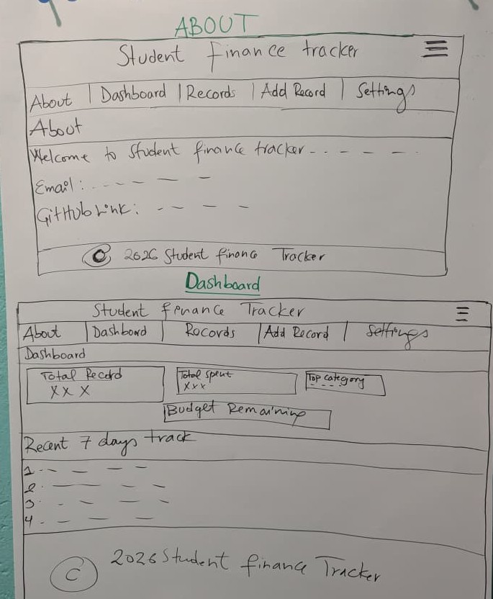

Wireframe 2 : Records & Add Record

Records Section
This page shows all saved transactions in a table. It has a search bar and sort dropdown at the top. The table columns are ID, Description, Amount, Category, Date and Actions. Each row has Edit and Delete buttons in the Actions column.

Add Record Section
This page contains a form to add a new transaction. It has input fields for Description, Amount, Category and Date. At the bottom there are Save Record and Cancel buttons.
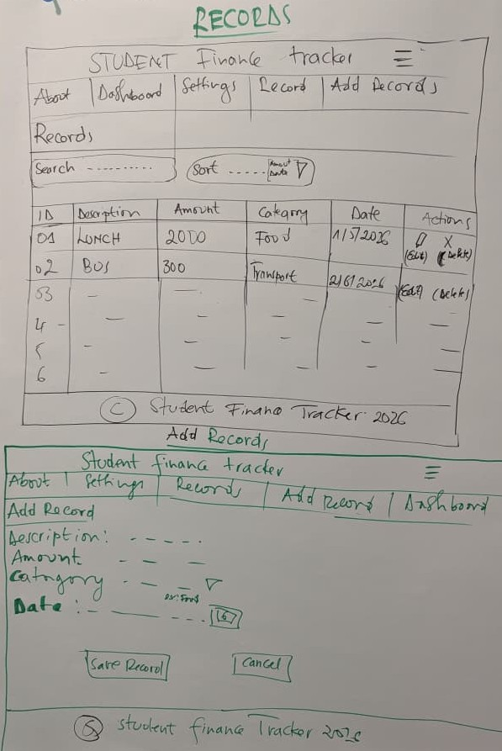

Wireframe 3 : Settings

Settings Section
This page allows the student to configure the app. It has input fields for Monthly Budget Plan in RWF, USD to RWF Rate and EUR to RWF Rate. There is a Save Settings button below the inputs. The Data Management section has Export File and Import File buttons for backing up and restoring data.
